JOB SEARCH PORTAL

ABSTRACT
Job portal service was developed for creating an interactive job vacancy form for candidates. This web application manage updates both from the job seekers as well as the companies. It’s unique development methodology helps in acquiring the client and candidate information and separating them according to the job requirements and vacancies. The online access to it provides details of the job. An employer being registered in the web site has the facility to use the services. Being an authorized user he can publish vacancy details and can search no of Employees on portal and also he can search candidates on basis of the key skill which employee provides on registration.

CONTENT
SNO | TITLE | PAGE NO
1 | INTRODUCTION
 | ORGANIZATION PROFILE
 | SYSTEM SPECIFICATION
 | HARDWARE CONFIGURATION
 | SOFTWARE SPECIFICATION
2 | SYSTEM STUDY
 | EXISTING SYSTEM
 | DRAWBACKS
 | PROPOSED SYSTEM
 | FEATURES
3 | SYSTEM DESIGN AND DEVELOPMENT
 | FILE DESIGN
 | INPUT DESIGN
 | OUTPUT DESIGN
 | DATABASE DESIGN
 | SYSTEM DEVELOPMENT
 | DESCRIPTION OF MODULES
4 | TESTING AND IMPLEMENTATION
5 | CONCLUSION BIBLIOGRAPHY
 | APPENDICES
 | A. DATA FLOW DIAGRAM
 | B. TABLE STRUCTURE
 | C. SAMPLE CODING
 | D. SAMPLE INPUT
 | E. SAMPLE OUTPUT

CHAPTER 1

- INTRODUCTION
INTRODUCTION:
ABOUT THE PROJECT:
Now a day, we know that searching of jobs is so difficult in proficient areas the portal developed for the providing the simple and good job searching. With the help of this portal easily the job seeker can submit their resume and get the lot of opportunity of the job related to their profile. And by this website the companies or employer can also find the good and well profiled resume.
Job Portal is the computerized online job search system developed to facilitate the General administration system to manage the various information. Like the Job Seeker and Job Provider and the processes involved in a placement company. Eventually, it contains all the information about the Company and Vacancy which is on this site. However, it contains all the information on Job Seeker like Personal Detail, Professional Detail, and Educational Detail etc. and evaluate jobs registered by companies. contain information related to Job expiry or re-registration. Maintain proper financial records. It should have an Administrator for scheduling administrative work of the site.
In today’s competitive environment, where everybody wants to be on the top, Information plays a very crucial role. As fast as information is accessed and processed, it can give good results. It has the features of providing all the information online (through the net). About the vacancy and about the seeker.

ABOUT THE ORGANIZATION:
Rapid Software House inaugurate as a student project center with lot of B.Tech, M.Tech, MBA, Polytechnic and Arts and Science students were migrated here for doing her/his final year project and mini project. Now, we are a leading expert in project development and IT solution in Tindivanam. We are also develop business process application, web Development, SEO, PHD project assistance, Andriod Applications, Cloud Servers, Technical Journals, Mechanical Resource Deputation and Placement, Image Processing, Wireless Communication. We pioneer in CSE, IT, ECE, MECHANICAL.
AIM:
- To provide quality education of information technology and IT enabled services to shine as leading business promoters on real time and submission of application and system software.
- To develop the efficient candidates as per the requirement of major IT sectors.
- To serve the society by releasing free wares.
- To provide a wide range of ideas and thoroughly to the environment about the development of information technology and its enabled fields.
MOTTO:
Our motto explains that even a middle class student can learn the booming technology which is highly costlier for them.

SYSTEM SPECIFICATIONS:
HARDWARE CONFIGURATIONS:-
The hardware used for the development of the project is:
    - PROCESSOR : PENTIUM - I3
    - RAM : 2 GB
    - HARD DISK : 500 GB
    - MOTHER BOARD : INTEL
    - KEY BOARD : LOGITECH B490
    - MOUSE : LOGITECH ( 3 Buttons)

SOFTWARE CONFIGURATIONS: -
The software used for the development of the project is:
  - OPERATING SYSTEM : Windows 8.1
  - FRONTEND : PHP v5.2
  - BACKEND : MYSQL Server 5.0
  - BROWSER : Internet Explorer

CHAPTER 2
SYSTEM STUDY
      - EXISTING SYSTEM
      - PROPOSED SYSTEM

EXISTING SYSTEM:
Job Procurement: Old and New Ways Job seeking usually involves different ways to look for jobs such as through personal contacts, direct telephone calls to employers, job agency office, scanning online job listings, etc. Before the Internet, became widely uses as a method of seeking jobs, jobseekers spent a lots of time using various methods to look for job openings. Today, jobseekers use online methods which are very convenient and save a lot of time. The traditional ways for recruitment:
1) Employment recruitment agencies
2) Job fairs
3) Advertising in the mass media such as newspapers
4) Management Consultants
5) Advertisement in television and radio
6) Existing employee contacts
7) Schools colleges or universities students services department
8) Workers or professional referrals
These old job seeking methods are too slow, stressful, challenging and also lack quality. In addition, the applicants have to consider the cost and the amount of time to get the information they need, and other preparations they have to make. Finding all available job vacancies is a main step at in the job-seeking process. The Internet is now a powerful tool that jobseekers can use. Today, there are many sites that advertise job positions to be filled by people with certain skills in various fields. The Internet plays an important role in the area of human resource planning and development. Most planning and development organizations are now using computer technology and the Internet for staff recruitment. It should be noted that although the Internet has facilitated the process of job-seeking, it has not replaced the traditional methods, completely.
Drawbacks of Existing System
In the age of technology, the Internet has become the main source of information for jobseekers. Large corporations, Institutions, and universities include information on career Prospects on their websites. According to a survey, 70% of the workforce uses websites or portals on the Internet to Search for jobs. These websites or portals provide search engine to access information on job opportunities.

PROPOSED SYSTEM
Online job portal is a web application built in PHP. It provides the candidates ability to register to this application and search for jobs, manage their accounts. Each candidate will have their own account with their own home page. On the other hand companies that are willing to publish the jobs for their company to candidates can register to the job portal and get their own account created and can post jobs to portal‘s database. Registered companies can add or remove jobs, various candidates can see these jobs, and they can contact the company person for the job. Main aim of this web application is to make a good web application that can make this job search option easy and accessible to everyone who is interested. Computerized on Line Job Search System is developed to facilitate the General administration system to manage the various information of the Job Provider and the processes involved in a placement company. So, that organization can access accurate information quickly and easily as and when required, thereby improving its operational efficiency & effectiveness. In today’s competitive environment, where everybody wants to be on the top, Information plays very crucial role. As fast as information is accessed and processed, it can give good results. Today Internet is the fast way of transferring Data and Information over wide area, hence I have used internet as a way for exchanging information’s computerized system helps to fulfill these goals. Computerization of the official works will help in doing lot of manual work quickly. It will help in easy storage and access of all information, in short period of time.

The advantages of the proposed system
The biggest advantage of a Job portal is that there is no fee for the job seeker. Websites like Monster.com thrive on the money that the companies pay to register with them. The job seeker just has to select the company he likes and apply to them. Of course, if a person wants to avail of other services like the resume service then he will have to pay extra. Portals are well organized and more often than not really help people get jobs. Most of them have a basic sign up procedure where the candidate can upload the resume and fill out all the important details about their educational backgrounds, skills and work experience. Everything is done in an orderly fashion and candidates can manages their own profiles and customize the site to meet their needs. One of the biggest advantages of a job portal is the fact that you can avoid certain companies or employers.
However, there are so many portals and so many jobs between them that it becomes difficult to manually apply for these jobs from every job portal on the internet. A quicker way of doing this would be to procure a program from the net, which can search for jobs through all these many sites and show the results in one window. There is software out there, which makes it possible for job seekers to find hundreds of opportunities in and around their areas and reply to these postings with a cover letter and the resume with just a few clicks. Software of this nature usually keeps the user informed with email alerts and reduces the time spent on job-hunting

CHAPTER 3
SYSTEM DESIGN AND DEVELOPMENT
      - FILE DESIGN
      - INPUT DESIGN
      - OUTPUT DESIGN
      - DATABASE DESIGN
      - SYSTEM DEVELOPMENT

FILE DESIGN:
1.Master file :
A master file is collection of records about an important aspect of an organizations activities. It may contain the data describes the current status of specific events or business indicators. For example, the master file in accounts payable system shows the balance owed to every vendor or suppliers. A second type of master file reflects the history of events affecting a particular entity. Suppose in any organization any employee leaves the organization at that time all the details of the employee must be stored. In computer such type of data or information are stored as history file. Master file are useful only so long as they are kept accurate and up to date.
2. Transaction file :
A transaction file is a temporary file with two purpose accumulating the data about events as they occurs and updating master files to reflect the results of current transactions. The term transactions refers to any business event that affects the organization and about which data are captured. Each transaction file contains only the records that pertain to the particular entities that are subject to the file. The details are accumulated as a record at a time in transaction file. The transaction and master file are read at the same time by a program and master file is revised depending upon the transactions.
Master files are permanent and exist as long as the system exists. However, the contents of the files change as a result of processing and updating. Transaction files, on the other hand, are temporary. At some time they are no longer needed and are erased or destroyed, depending upon the method used for time durations.

3. Table file :
A special type of master file is included in many systems to meet special processing requirements involving data that must be referenced repeatedly. Table files contain reference data used in processing transactions, updating master files, or producing output. Analyst often specify the use of table files to store data that otherwise would be included in master files or embedded in computer program. Table file conserve storage space and ease program maintenance by storing in a file data that otherwise would be included in programs or master file.
4. Report file :
The central processing unit of computer very often produces data for output at a faster rate than the printer can possibly keep up with. Following the normal sequence of events, processing would have to be delayed while the result are printed. To prevent such inefficient use of the cpu, the analyst generates the output in a text file called the report file. Report files are temporary files used when printing time is not available for all the reports produced, a situation that frequently arises in overlapped processing. The computer writes the output to a file on
secondary storage. This file will be used whenever it is required and will be deleted when the use of the file is over.
5.Other files :
Other kind of files, as well as special uses of the file types previously discussed, play a role in information system. For example a backup file is a copy of master file , transaction file or table file made to ensure that duplicate is available if anything happens to the original file.

Methods of file organization
Records are stored in files using a file organization that determines how the records will be stored, located and retrieved. There are basically three methods to store the records are as follow :
- Sequential organizations : It is the simplest way to store and retrieve records in a file. In a sequential file records are stored one after the other without concern for the actual value of the data in the records. The first record is stored at the beginning of the file. The second record is stored right after the first record and so on. This order never change in sequential file organization. A characteristic of sequential file is that all records are stored by position: first record, second record and so on. There are no addresses or location assignments in sequential file.
- Direct access organization : This method requires the program to tell the system where a record is stored before it can access the record. In contrast to sequential organization, processing a direct access file does not require the system to start at the first record in the file. Using the record key as the storage address is called direct addressing.
- Indexed organization : A third way of accessing records is through an index. The basic form of index includes a record key and the storage address for a record. To find a record when the storage address is unknown it is necessary to scan the records. However the search will be faster if an index is used, since it takes less time to search an index than an
entire file.

INPUT DESIGN:

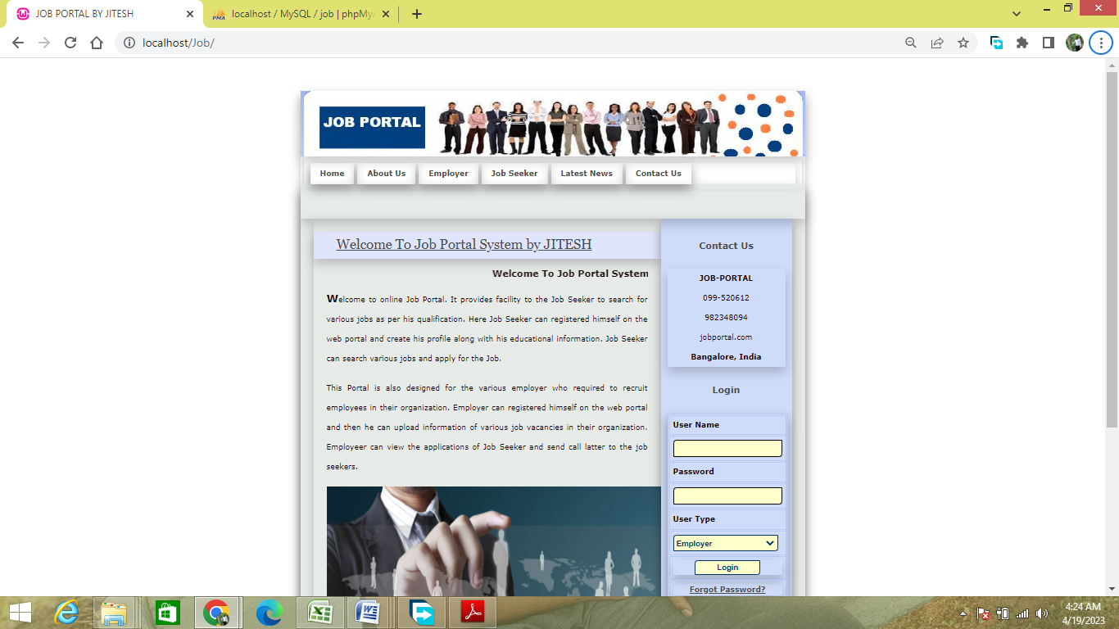

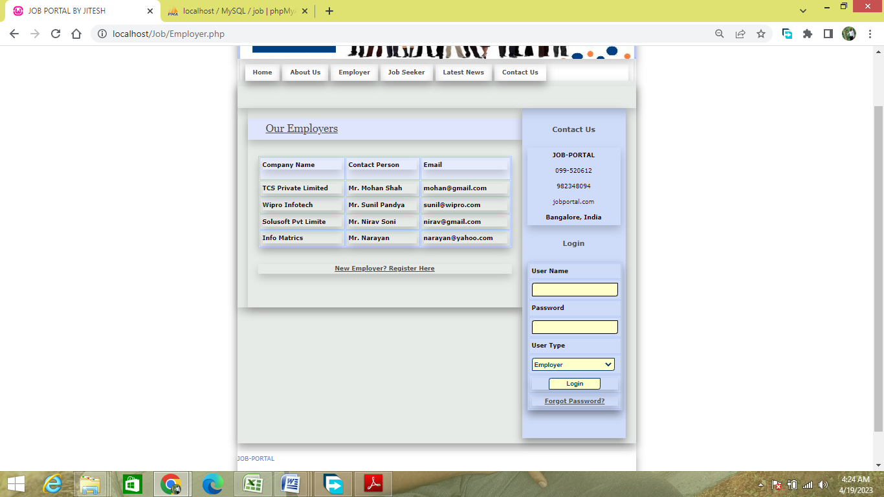

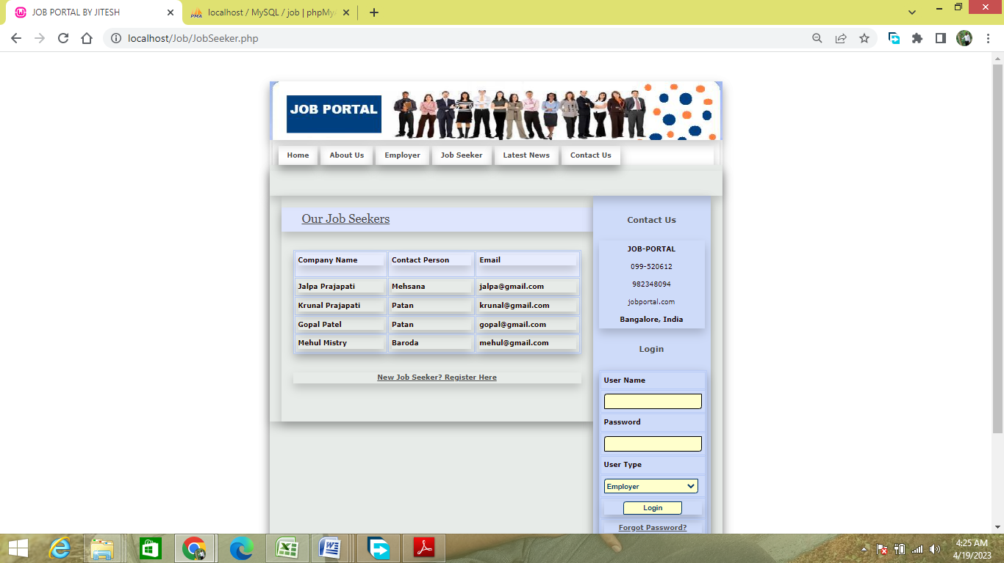

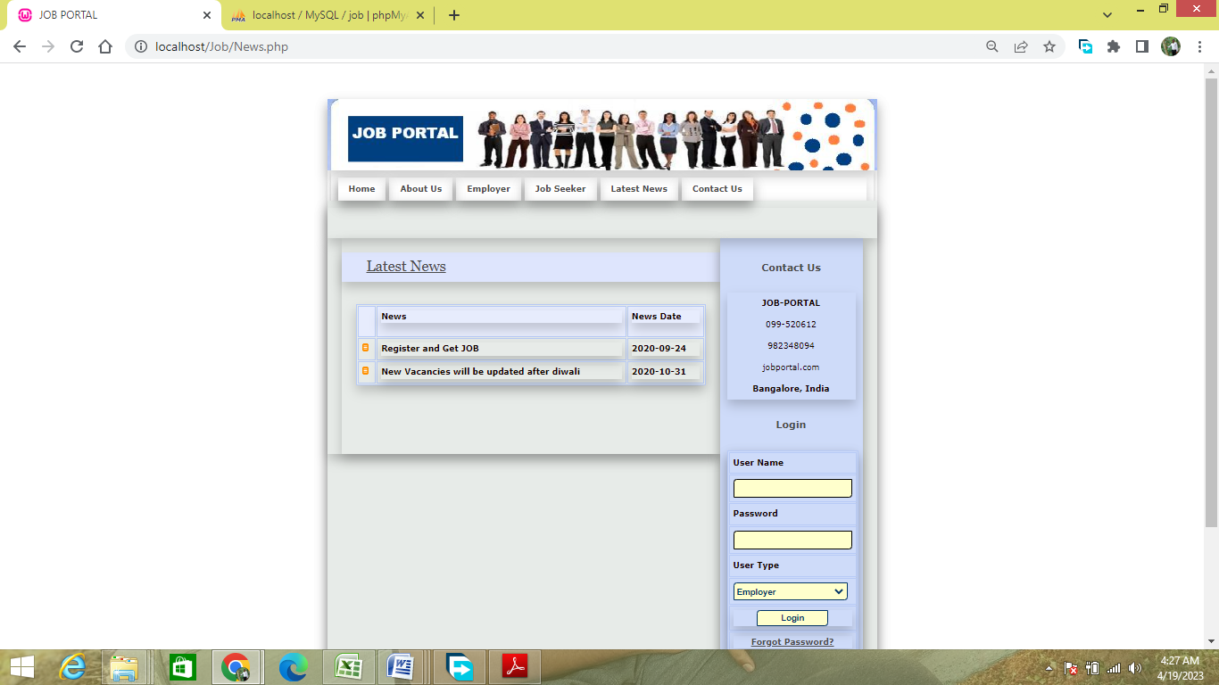

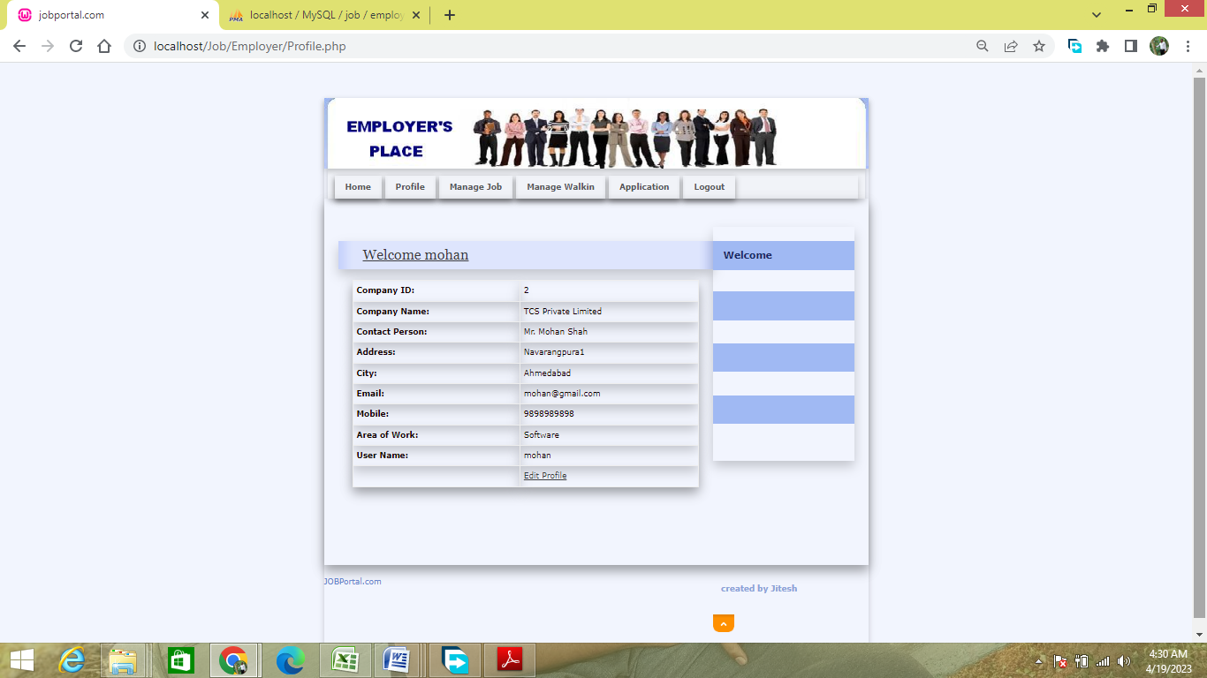

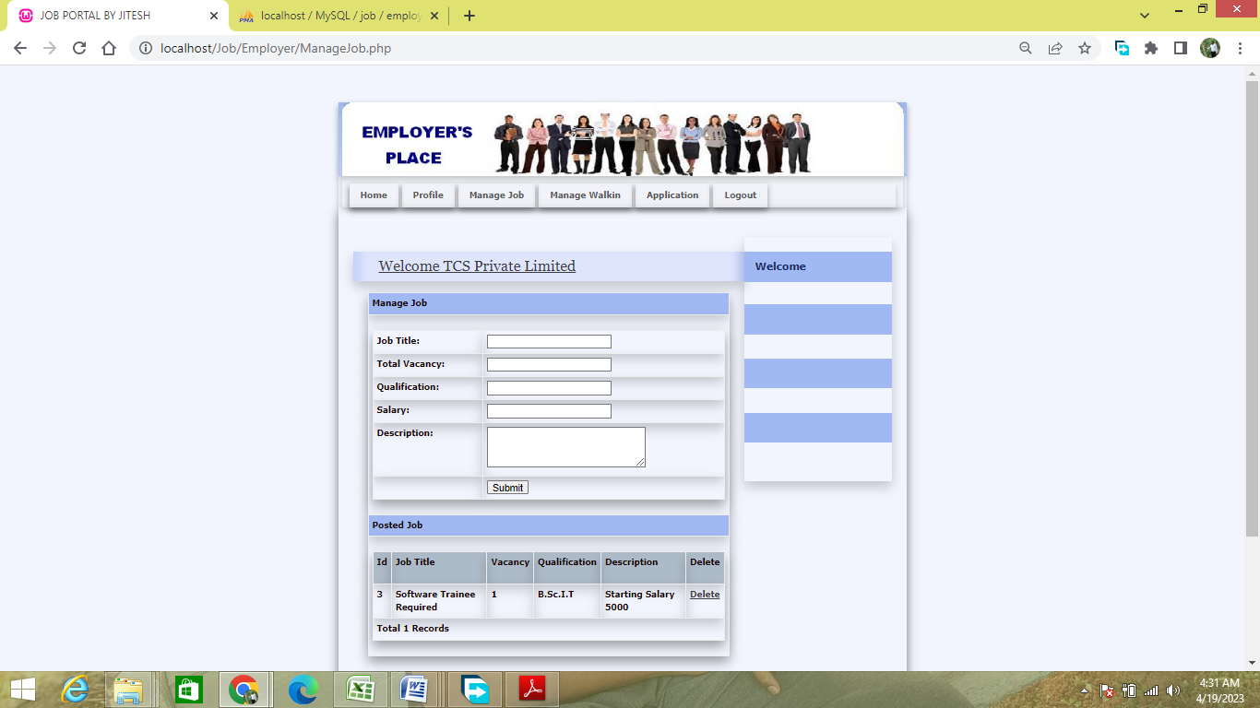

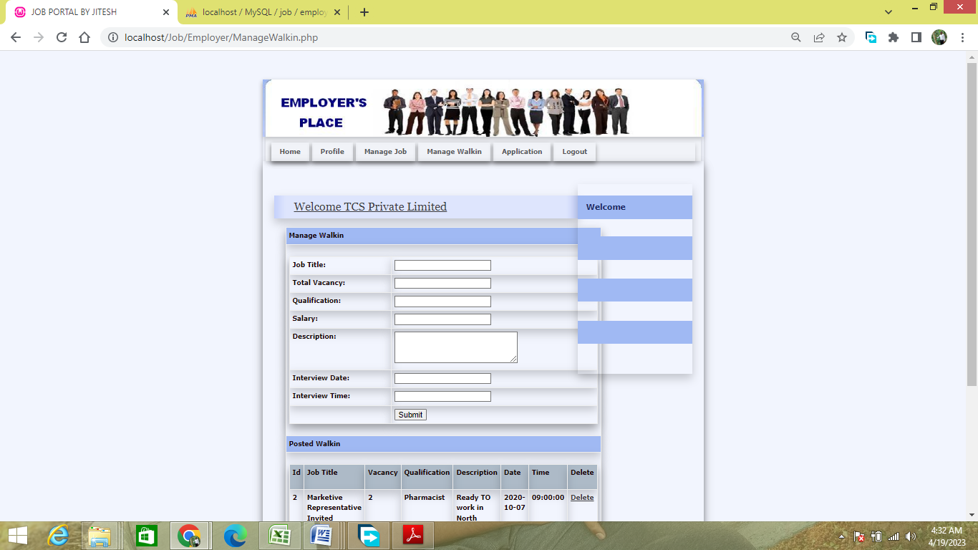

SYSTEM DEVELOPMENT:
DESCRIPTION OF MODULES:
Registration
In the registration module job seeker have to include all the details like personal details, contact details, education details like school , graduation, post-graduation, course certification details etc. Also job seeker has to add his experience details, job requirements and uploading resume and photo.
While job recruiter has to add his contact details and organization details for the registration and upload company logo and profile.
Job Post
Employer can post a job by providing all the job details like qualifications details, requirements for the job, designation details, job salary details and also provide type of jobs. They also can delete the jobs whenever they want. After successfully posted a job it will be available for all the job seekers who are searching for a job. And it will be available on home page as recently posted job.
Search
Employee Can Search job according to their interest. And also apply for that job or they can add into wishlist for future whenever they find for job for that company then they easily find out company from wishlist.
Employer search candidates for their requirements using keyword like technology. And also can communicate with employee for their any other query or information via send message .and also employer see the resume of applicants.
Manage Account
While employers can manage their job postings. And providing all the job details like qualifications details, requirements for the job, designation details, job salary details and also provide type of jobs. They also can delete the jobs whenever they want.
While employee can manage their wishlist, applied for job and also getting full details of employer. Employees can delete their account anytime. Also they can apply for the different jobs according to their interests

CHAPTER 4
TESTING AND IMPLEMENTATION

TESTING
The purpose of testing is to discover errors. Testing is the process of trying to discover every conceivable fault or weakness in a work product. It provides a way to check the functionality of components, sub-assemblies, assemblies and/or a finished product. It is also the process of exercising software with the intent of ensuring that the it meets its requirements, user expectations and does not fail in an unacceptable manner. There are various types of test that can be performed. Each type of test addresses a specific testing requirement.
Types of Tests
Unit testing.
Unit testing involves the design of test cases that validate that the internal program logic is functioning properly, and that the program inputs produce valid outputs. All decision branches and internal code flow should be validated by this test. It is the testing of individual software units of the application. It is done after the completion of an individual unit but before integration. This is a structural test, that relies on knowledge of its construction and it is invasive. Unit tests perform basic tests at the component level and test a specific business process, application, and/or system configuration. Unit tests also ensure that each unique path of a business process performs accurately to the documented specifications and contains clearly defined inputs and expected results.
Unit testing is usually conducted as part of a combined code and unit test phase of the software lifecycle, although it is not uncommon for coding and unit testing to be conducted in two distinct phases. Test strategy and approach. Field testing will be performed manually, and functional tests will be written in detail.

Test objectives
- All field entries must work properly.
- Pages must be activated from the identified link.
- The entry screen, messages and responses must not be delayed.
- Features to be tested
- Verify that the entries are of the correct formats
- No duplicate entries should be allowed.
- All links should take the user to the correct page.

Integration testing.
Integration tests are designed to test integrated software components to determine if they run as one cohesive program. Testing is event driven and is more concerned with the basic outcome of screens or fields. Integration tests demonstrate that although the components were individually satisfactory, as shown by successful unit testing, the combination of components is performing correctly and consistently. Integration testing is specifically aimed at exposing the problems that arise from the combination of these components. Software integration testing is the incremental integration testing of two or more integrated software components on a single platform to produce failures caused by interface defects.
The task of the integration test is to check that components or software applications, e.g. components in a software system or – one step up – software applications at the company level interact without error. All the test cases mentioned above passed successfully, and no defects were encountered.
Acceptance testing.
User acceptance testing is a critical phase of any project and requires significant participation by the end user. It also ensures that the system meets the functional requirements. All the test cases mentioned above passed successfully, and no defects were encountered.
Functional testing.
Functional tests provide systematic demonstrations that functions tested are available as specified by the business and technical requirements, system documentation, and user manuals. Functional testing is centered on the following items:
- Valid Input: identified classes of valid inputs must be accepted.
- Invalid Input: identified classes of invalid inputs must be rejected.
- Functions: identified functions must be exercised.
- Output: identified classes of application outputs must be exercised.
- Systems/Procedures: interfacing systems or procedures must be invoked.
The organization and preparation of functional tests is focused on requirements, key functions, or special test cases. In addition, the systematic coverage pertaining to identifying business process flows; data fields, predefined processes, and successive processes must be considered for testing. Before functional testing is complete, additional tests are identified and the effective value of current tests is determined.

System testing.
System testing ensures that the entire integrated software system meets requirements. It tests a configuration to ensure known and predictable results. An example of system testing is the configuration-oriented system integration test. System testing is based on process descriptions and flows, emphasizing pre-driven process links and integration points. There will be different layers to test and this system testing comes under a higher environment and will have restricted access to normal testers.
White box testing.
White box testing is a test in which the software tester has knowledge of the inner workings, structure and language of the software, or at least its purpose. Its purpose is used to test areas that cannot be reached from a black box level.
Black box testing.
Black box testing is a test of the software without any knowledge of the inner workings, structure or language of the module being tested. Black box tests, as with most other kinds of tests, must be written from a definitive source document, such as a specification or requirements document. It is a test in which the software under test is treated, as a black box. You cannot “see” into it. The test provides inputs and responds to outputs without considering how the software works.

CHAPTER 5
CONCLUSION AND BIBLIOGRAPHY

CONCLUSION:
It has been a great pleasure for me to work on this exciting and challenging project. This project proved good for me as it provided practical knowledge of not only programming in PHP web based application and no some extent Windows Application and MySQL Server, but also about all handling procedure related with online job portal. It also provides knowledge about the latest technology used in developing web enabled application and client server technology that will be great demand in future. This will provide better opportunities and guidance in future in developing projects independently.

REFERENCES:
- WHATWG (Web HyperText Application Working Group) HTML Specfication @ https://html.spec.whatwg.org/multipage/.
- CSS 2.1 Specification W3C Recommendation Revised 17 December 2014 (@ https://www.w3.org/TR/CSS21/).
- W3C CSS Specification @ https://www.w3.org/Style/CSS/specs.en.html.
- W3School's JavaScript Tutorials, References and Examples @ https://www.w3schools.com/.
- PHP mother site @ http://php.net/.
- PHP Manual @ http://php.net/manual/en/.
- PHP Language Reference @ http://php.net/manual/en/langref.php.
- MySQL Mother Site @ www.mysql.com.
- MySQL 5.7 "Reference Manual" @ http://dev.mysql.com/doc/.
- MySQL 5.7 "SQL Statement Syntax" @ http://dev.mysql.com/doc/refman/5.7/en/sql-syntax.html.

APPENDICES
- DATA FLOW DIAGRAM:

ER DIAGRAM

- TABLE STRUCTURE:

Table Name: application_master
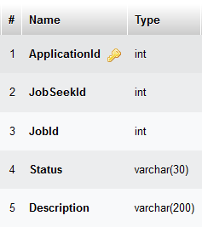

Table Name: employee_reg
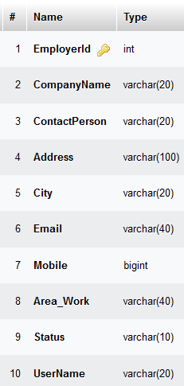

Table Name: jobmaster

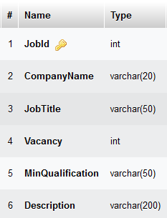

- SAMPLE CODING:
FileName: index.php:
<?php
session_start();
if(isset($_SESSION['$UserName'])){
header('location:Admin/index.php');
}
if(isset($_SESSION['$UserName_job'])){
header('location:JobSeeker/index.php');
}
if(isset($_SESSION['$UserName_emp'])){
header('location:Employer/index.php');
}
?>

<!DOCTYPE html PUBLIC "-//W3C//DTD XHTML 1.0 Strict//EN" "http://www.w3.org/TR/xhtml1/DTD/xhtml1-strict.dtd">
<html xmlns="http://www.w3.org/1999/xhtml" xml:lang="cs" lang="cs">
<head>
<meta http-equiv="content-type" content="text/html; charset=utf-8" />
<meta http-equiv="content-language" content="cs" />
<meta name="robots" content="all,follow" />

<title>JOB PORTAL</title>
<meta name="description" content="..." />
<meta name="keywords" content="..." />

<link rel="index" href="./" title="Home" />
<link rel="stylesheet" media="screen,projection" type="text/css" href="./css/main.css" />
<link rel="stylesheet" media="print" type="text/css" href="./css/print.css" />
<link rel="stylesheet" media="aural" type="text/css" href="./css/aural.css" />
<style type="text/css">
<!--
.style1 {
color: #000066;
font-weight: bold;
}
.style2 {
font-size: medium;
font-weight: bold;
}
-->
</style>
</head>

<body id="www-url-cz">
<!-- Main -->
<div id="main" class="box">
<?php
include "Header.php"
?>
<?php
include "menu.php"
?>
<!-- Page (2 columns) -->
<div id="page" class="box">
<div id="page-in" class="box">

<div id="strip" class="box noprint">

<!-- RSS feeds -->
<hr class="noscreen" />

<!-- Breadcrumbs -->
<p id="breadcrumbs">&nbsp;</p>
<hr class="noscreen" />

</div> <!-- /strip -->

<!-- Content -->
<div id="content">

<!-- /article -->

<hr class="noscreen" />

<!-- /article -->

<hr class="noscreen" />

<!-- Article -->

<!-- /article -->

<hr class="noscreen" />

<!-- Article -->
<div class="article">
<h2><span><a href="#">Welcome To Job Portal System </a></span></h2>
<h3><marquee>Welcome To Job Portal System by Vijay</marquee></h3>

<p> <span class="style2">W</span>elcome to online Job Portal. It provides facility to the Job Seeker to search for various jobs as per his qualification. Here Job Seeker can registered himself on the web portal and create his profile along with his educational information. Job Seeker can search various jobs and apply for the Job.</p>
<p>This Portal is also designed for the various employer who required to recruit employees in their organization. Employer can registered himself on the web portal and then he can upload information of various job vacancies in their organization. Employeer can view the applications of Job Seeker and send call latter to the job seekers.</p>
<p align="right"> <img src="design/banner-4.jpg" alt="" width="510" height="300" /></p>
<p class="btn-more box noprint">&nbsp;</p>
</div> <!-- /article -->

<hr class="noscreen" />

</div> <!-- /content -->

<?php
include "right.php"
?>

</div> <!-- /page-in -->
</div> <!-- /page -->

<?php
include "footer.php"
?>
</div> <!-- /main -->

</body>
</html>

FileName: jobseeker.php

<!DOCTYPE html PUBLIC "-//W3C//DTD XHTML 1.0 Strict//EN" "http://www.w3.org/TR/xhtml1/DTD/xhtml1-strict.dtd">
<html xmlns="http://www.w3.org/1999/xhtml" xml:lang="cs" lang="cs">
<head>
<meta http-equiv="content-type" content="text/html; charset=utf-8" />
<meta http-equiv="content-language" content="cs" />
<meta name="robots" content="all,follow" />

<title>JOB PORTAL BY JITESH</title>
<meta name="description" content="..." />
<meta name="keywords" content="..." />

<link rel="index" href="./" title="Home" />
<link rel="stylesheet" media="screen,projection" type="text/css" href="./css/main.css" />
<link rel="stylesheet" media="print" type="text/css" href="./css/print.css" />
<link rel="stylesheet" media="aural" type="text/css" href="./css/aural.css" />
<style type="text/css">
<!--
.style1 {
color: #000066;
font-weight: bold;
}
.style2 {font-weight: bold}
-->
</style>
</head>

<body id="www-url-cz">
<SCRIPT language="JavaScript1.2" src="gen_validation.js"></SCRIPT>
<SCRIPT language="JavaScript1.2">
var arrFormValidation=
[
[//Name
["minlen=1",
"Please Enter Name "
]

],
[//Address
["minlen=1",
"Please Enter Address "
]

],
[//Country

],
[//State

],
[//City

],
[//Mobile

["num",
"Please Enter valid Mobile "
],
["minlen=10",
"Please Enter valid Mobile "
]

],
[//Email
["minlen=1",
"Please Enter Email "
],
["email",
"Please Enter valid email "
]

],
[//ID

],
[//TDType

["minlen=1",
"Please Select File "
]

],
[//UserName

["minlen=1",
"Please Enter UserName "
]
],
[//Password

["minlen=1",
"Please Enter Password "
]

],
[//Confirm

["minlen=1",
"Please Enter Confirm Password "
]

]
];
</SCRIPT>
<!-- Main -->
<div id="main" class="box">
<?php
include "Header.php"
?>
<?php
include "menu.php"
?>
<!-- Page (2 columns) -->
<div id="page" class="box">
<div id="page-in" class="box">

<div id="strip" class="box noprint">

<!-- RSS feeds -->
<hr class="noscreen" />

<!-- Breadcrumbs -->
<p id="breadcrumbs">&nbsp;</p>
<hr class="noscreen" />

</div> <!-- /strip -->

<!-- Content -->
<div id="content">

<!-- /article -->

<hr class="noscreen" />

<!-- /article -->

<hr class="noscreen" />

<!-- Article -->

<!-- /article -->

<hr class="noscreen" />

<!-- Article -->
<div class="article">
<h2><span><a href="#">Our Job Seekers</a></span></h2>

<p>
<table width="100%" border="1" cellpadding="1" cellspacing="2" bordercolor="#006699" >
<tr>
<th height="32" bgcolor="#006699" class="style3"><div align="left" class="style9 style5 style2"><strong>Company Name</strong></div></th>
<th bgcolor="#006699" class="style3"><div align="left" class="style9 style5 style2"><strong>Contact Person</strong></div></th>
<th bgcolor="#006699" class="style3"><div align="left" class="style9 style5 style2"><strong>Email</strong></div></th>
</tr>
<?php
// Establish Connection with Database
$con = mysqli_connect("localhost","root","","job");
// Select Database
//mysqli_select_db("job", $con);
// Specify the query to execute
$sql = "select * from jobseeker_reg where Status='Confirm'";
// Execute query

$result = mysqli_query($con,$sql);

//var_dump($result);

// Loop through each records
while($row = mysqli_fetch_array($result))
{
$Name=$row['JobSeekerName'];
$City=$row['City'];
$Email=$row['Email'];

?>
<tr>
<td class="style3"><div align="left" class="style9 style5"><strong><?php echo $Name;?></strong></div></td>
<td class="style3"><div align="left" class="style9 style5"><strong><?php echo $City;?></strong></div></td>
<td class="style3"><div align="left" class="style9 style5"><strong><?php echo $Email;?></strong></div></td>
</tr>
<?php
}
// Retrieve Number of records returned
$records = mysqli_num_rows($result);
?>

<?php
// Close the connection
mysqli_close($con);
?>
</table>
</td>
</tr>
</table>
</p>

<div align="center"><a href="JobSeekerReg.php"><strong>New Job Seeker? Register Here</strong></a> </div>
<p class="btn-more box noprint">&nbsp;</p>
</div> <!-- /article -->

<hr class="noscreen" />

</div> <!-- /content -->

<?php
include "right.php"
?>

</div> <!-- /page-in -->
</div> <!-- /page -->

<?php
include "footer.php"
?>
</div> <!-- /main -->

</body>
</html>

File Name: login.php
<!DOCTYPE html PUBLIC "-//W3C//DTD XHTML 1.0 Transitional//EN" "http://www.w3.org/TR/xhtml1/DTD/xhtml1-transitional.dtd">
<html xmlns="http://www.w3.org/1999/xhtml">
<head>
<meta http-equiv="Content-Type" content="text/html; charset=utf-8" />
<title>Untitled Document</title>
</head>

<body>
<?php
session_start();
$UserName=$_POST['txtUser'];
$Password=$_POST['txtPass'];
$UserType=$_POST['cmbUser'];
if($UserType=="Administrator")
{
$con = mysqli_connect("localhost","root","","job");

$sql = "select * from user_master where UserName='".$UserName."' and Password='".$Password."'";
$result = mysqli_query($con,$sql);
$records = mysqli_num_rows($result);
$row = mysqli_fetch_array($result);
if ($records==0)
{
echo '<script type="text/javascript">alert("Wrong UserName or Password");window.location=\'index.php\';</script>';
}
else
{
$_SESSION['$UserName']=$UserName;
header("location:Admin/index.php");
}
mysqli_close($con);
}
else if($UserType=="JobSeeker")
{
$con = mysqli_connect("localhost","root","","job");
$sql = "select * from jobseeker_reg where UserName='".$UserName."' and Password='".$Password."' and Status='Confirm'";
$result = mysqli_query($con,$sql);
$records = mysqli_num_rows($result);
$row = mysqli_fetch_array($result);
if ($records==0)
{
echo '<script type="text/javascript">alert("Wrong UserName or Password");window.location=\'index.php\';</script>';
}
else
{
$_SESSION['ID']=$row['JobSeekId'];
$_SESSION['Name']=$row['JobSeekerName'];
$_SESSION['$UserName_job']=$UserName;
header("location:JobSeeker/index.php");
}
mysqli_close($con);
}
else
{
$con = mysqli_connect("localhost","root","","job");
$sql = "select * from employer_reg where UserName='".$UserName."' and Password='".$Password."' and Status='Confirm'";
$result = mysqli_query($con,$sql);
$records = mysqli_num_rows($result);
$row = mysqli_fetch_array($result);
if ($records==0)
{
echo '<script type="text/javascript">alert("Wrong UserName or Password");window.location=\'index.php\';</script>';
}
else
{
$_SESSION['ID']=$row['EmployerId'];
$_SESSION['Name']=$row['CompanyName'];
$_SESSION['$UserName_emp']=$UserName;
header("location:Employer/index.php");
}
mysqli_close($con);
}
?>

</body>
</html>

FileName: News.php
<!DOCTYPE html PUBLIC "-//W3C//DTD XHTML 1.0 Strict//EN" "http://www.w3.org/TR/xhtml1/DTD/xhtml1-strict.dtd">
<html xmlns="http://www.w3.org/1999/xhtml" xml:lang="cs" lang="cs">
<head>
<meta http-equiv="content-type" content="text/html; charset=utf-8" />
<meta http-equiv="content-language" content="cs" />
<meta name="robots" content="all,follow" />

<title>JOB PORTAL</title>
<meta name="description" content="..." />
<meta name="keywords" content="..." />

<link rel="index" href="./" title="Home" />
<link rel="stylesheet" media="screen,projection" type="text/css" href="./css/main.css" />
<link rel="stylesheet" media="print" type="text/css" href="./css/print.css" />
<link rel="stylesheet" media="aural" type="text/css" href="./css/aural.css" />
<style type="text/css">
<!--
.style1 {
color: #000066;
font-weight: bold;
}
.style2 {font-weight: bold}
-->
</style>
</head>

<body id="www-url-cz">
<!-- Main -->
<div id="main" class="box">
<?php
include "Header.php"
?>
<?php
include "menu.php"
?>
<!-- Page (2 columns) -->
<div id="page" class="box">
<div id="page-in" class="box">

<div id="strip" class="box noprint">

<!-- RSS feeds -->
<hr class="noscreen" />

<!-- Breadcrumbs -->
<p id="breadcrumbs">&nbsp;</p>
<hr class="noscreen" />

</div> <!-- /strip -->

<!-- Content -->
<div id="content">

<!-- /article -->

<hr class="noscreen" />

<!-- /article -->

<hr class="noscreen" />

<!-- Article -->

<!-- /article -->

<hr class="noscreen" />

<!-- Article -->
<div class="article">
<h2><span><a href="#">Latest News</a></span></h2>

<p>
<table width="100%" border="1" cellpadding="1" cellspacing="2" bordercolor="#006699" >
<tr>
<th bgcolor="#006699" class="style3">&nbsp;</th>
<th height="32" bgcolor="#006699" class="style3"><div align="left" class="style9 style5 style2"><strong>News</strong></div></th>
<th bgcolor="#006699" class="style3"><div align="left" class="style9 style5 style2"><strong>News Date</strong></div></th>
</tr>
<?php
// Establish Connection with Database
$con = mysqli_connect("localhost","root","","job");
// Select Database

// Specify the query to execute
$sql = "select * from news_master";
// Execute query
$result = mysqli_query($con,$sql) or die( mysqli_error($con));
// Loop through each records
while($row = mysqli_fetch_array($result))
{
$News=$row['News'];
$NewsDate=$row['NewsDate'];

?>
<tr>
<td class="style3"><img src="design/ico_archive2.gif" alt="" width="9" height="11" /></td>
<td class="style3"><div align="left" class="style9 style5"><strong><?php echo $News;?></strong></div></td>
<td class="style3"><div align="left" class="style9 style5"><strong><?php echo $NewsDate;?></strong></div></td>
</tr>
<?php
}
// Retrieve Number of records returned
$records = mysqli_num_rows($result);
?>

<?php
// Close the connection
mysqli_close($con);
?>
</table>
</td>
</tr>
</table>
</p>
<p class="btn-more box noprint">&nbsp;</p>
</div> <!-- /article -->

<hr class="noscreen" />

</div> <!-- /content -->

<?php
include "right.php"
?>

</div> <!-- /page-in -->
</div> <!-- /page -->

<?php
include "footer.php"
?>
</div> <!-- /main -->

</body>
</html>
FileName: employeeinsert.php
<!DOCTYPE html PUBLIC "-//W3C//DTD XHTML 1.0 Transitional//EN" "http://www.w3.org/TR/xhtml1/DTD/xhtml1-transitional.dtd">
<html xmlns="http://www.w3.org/1999/xhtml">
<head>
<meta http-equiv="Content-Type" content="text/html; charset=utf-8" />
<title>Untitled Document</title>
</head>

<body>
<?php

$CompnayName=$_POST['txtName'];
$ContactPerson=$_POST['txtPerson'];
$Address=$_POST['txtAddress'];
$City=$_POST['txtCity'];
$Email=$_POST['txtEmail'];
$Mobile=$_POST['txtMobile'];
$Area=$_POST['txtAreaWork'];
$Status="Pending";
$UserName=$_POST['txtUserName'];
$Password=$_POST['txtPassword'];
$UserType="Employer";
$Question=$_POST['cmbQue'];
$Answer=$_POST['txtAnswer'];
// Establish Connection with MYSQL
$con = mysqli_connect ("localhost","root","","job");

// Specify the query to Insert Record
$sql = "insert into employer_reg(CompanyName,ContactPerson,Address,City,Email,Mobile,Area_Work,Status,UserName,Password,Question,Answer) values('".$CompnayName."','".$ContactPerson."','".$Address."','".$City."','".$Email."',".$Mobile.",'".$Area."','".$Status."','".$UserName."','".$Password."','".$Question."','".$Answer."')";
// execute query

mysqli_query ($con,$sql);
// Close The Connection
mysqli_close ($con);

echo '<script type="text/javascript">alert("Registration Completed Succesfully");window.location=\'index.php\';</script>';

?>
</body>
</html>
- SAMPLE INPUT:

SAMPLE OUTPUT:

